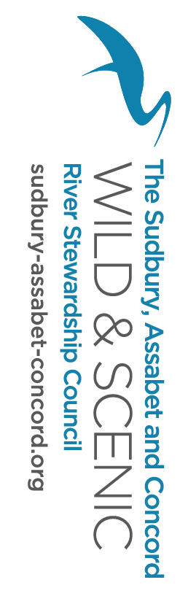
River Stewardship Council
Monthly Meeting
Sept 24th, 2019
Sudbury Valley Trustees
7:00 – 9:00 PM

Meeting Agenda
7:00 Introductions Anne
Meeting Minutes

7:10 Appreciation for Karen Pelto! Anne

7:20 Small group work groups, updates and next steps:
- Recreation and Access outreach letter Marlies
- Stewardship Elissa
- 2 needs – Riverfest Eval, River Clearing Sarah

7:45 Riverfest wrap-up

8:00 Community Grant Announcement –
- Reach for announcement – sign-ups
- Previous recipients finding funding?

8:15 Budget wrap-up from FY19 (Mussel study delay, Extensions) Anne and Sarah

8:30 Talbot Mill Dam happenings and Thor’s talk

8:45 Ongoing Business Items:
- W&S Rivers Partnership Meeting – Nat’l updates, PWSR program growth, Report Card pres.
- River clearing/OARS cleanup – Bill
- DER celebration on river, State rep recruitment
- Cost-share application
- Farm Pond – Ron
- Membership check-ins – Anne
- Wayland Town report

